2019 Postseason NIVC Team Contact Information
Please email contact information back to Jared Rudiger @ Jared@triplecrownsports.com by November 25th, 2019

NAME
OFFICE PHONE
(555-555-5555)
CELL PHONE
(555-555-5555)
E-MAIL ADDRESS
Athletic Dept. Contact (who oversees Volleyball )
Head Volleyball Coach
Game or Tournament Manager
Director of Operations – Volleyball
Volleyball Sports Information Contact (SID)
Facility Director Contact
At
hletics (Volleyball) Mailing Address: (street/city/st/zip)
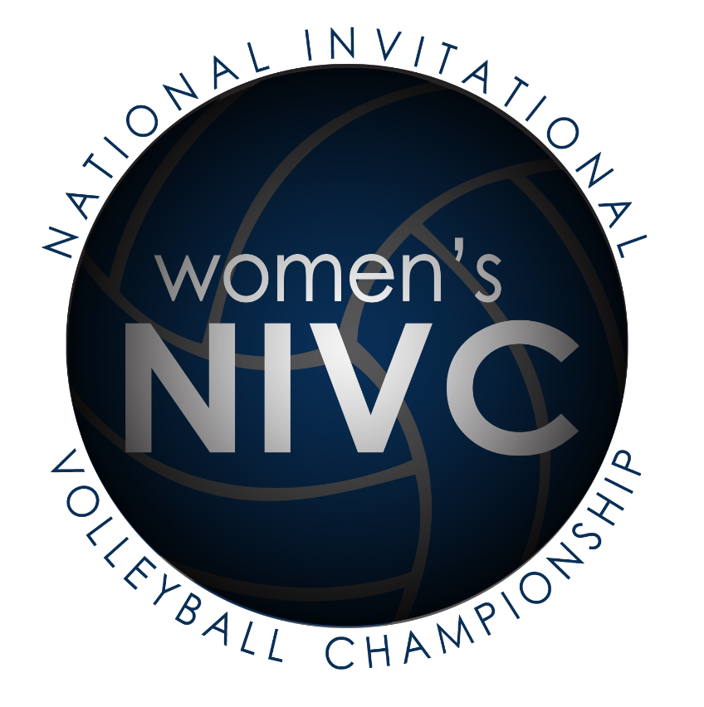
For internal office use only by the NIVC

